Task 1: Operators
- Create the following methods inside the Operators class:
• Add(int a, int b) — prints the sum of two numbers
• Subtract(int a, int b) — prints the difference
• Multiply(int a, int b) — prints the product
• Divide(int a, int b) — prints the result of division
- Create another method inside the same class:
• OddEvenFinder(int number) — determines whether the given number is
Odd or Even using the Ternary Operator (? :) and prints the message
"Even Number" or "Odd Number" .
- In Program.cs:
• Call all the methods of the Operators class.

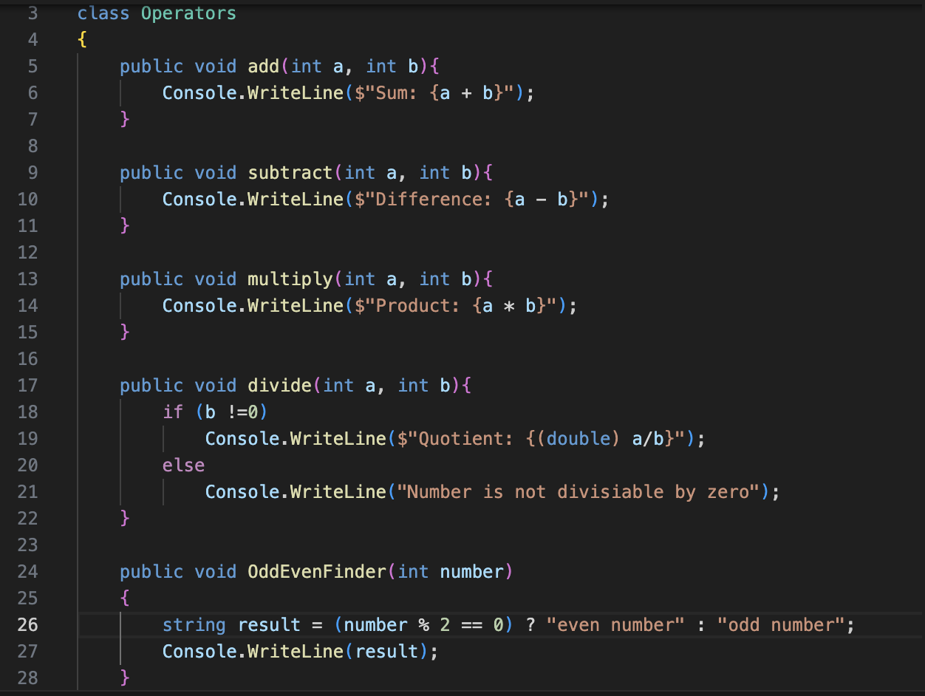

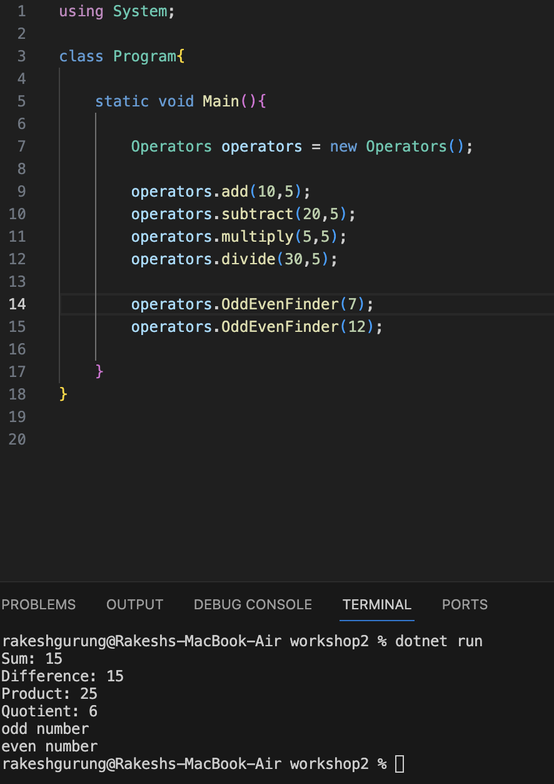
Task 2: Null Operations
- Inside the class NullOperations, create a method named PerformNullChecks()
that performs the following tasks:
- Declare a string variable named username and assign null to it.
- Use the Ternary Operator (? :) to check whether username is null:
• If username is null, print: "Username is not available".
Otherwise, print the value of username.
- Perform the same null checking using the Null-Coalescing Operator (??).
- Use the Null-Coalescing Assignment Operator (??=) to assign a value to
username only if it is currently null.
• After assignment, print the updated value of username.
- Finally, call the PerformNullChecks() method from Program.cs.

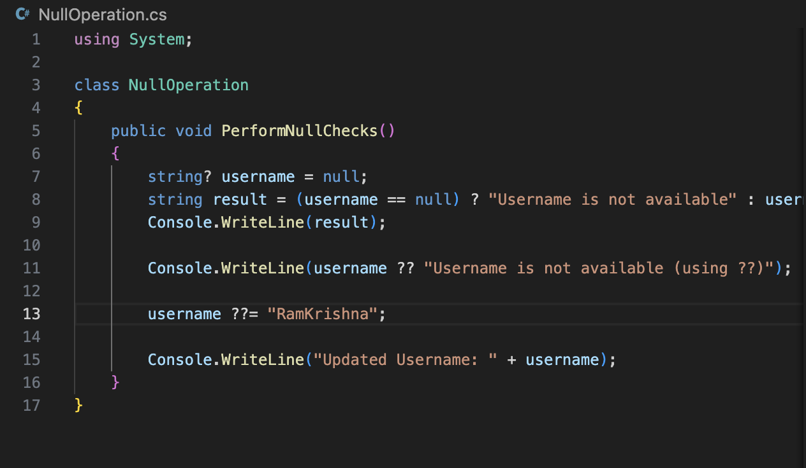
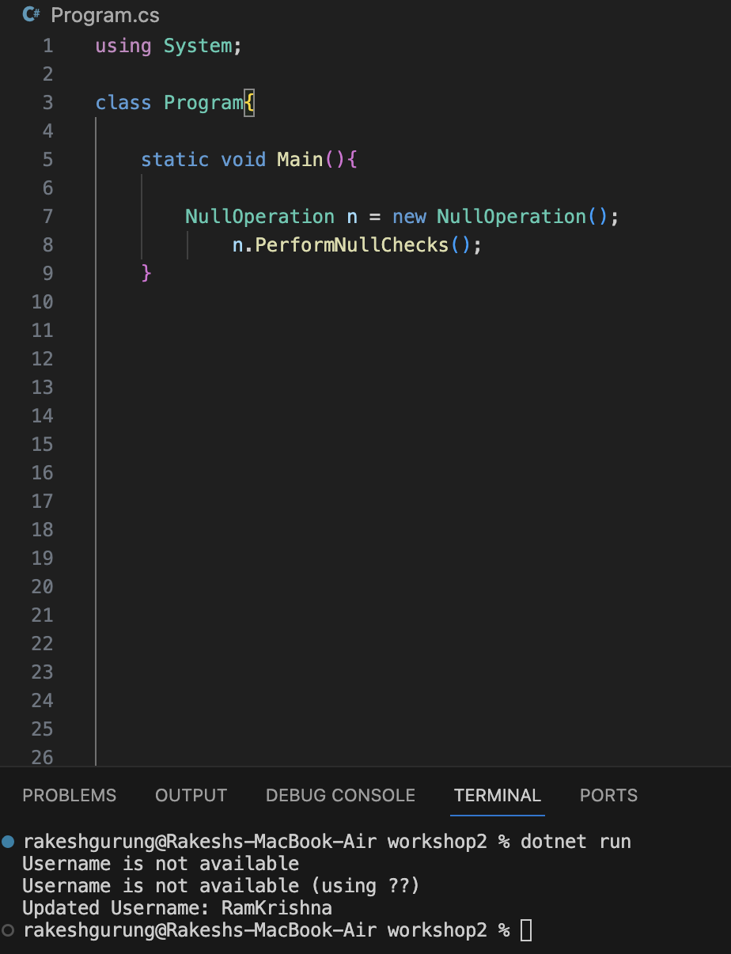

Task 3: If Else and Switch
1. Ask user to input age and using if – else – if display:
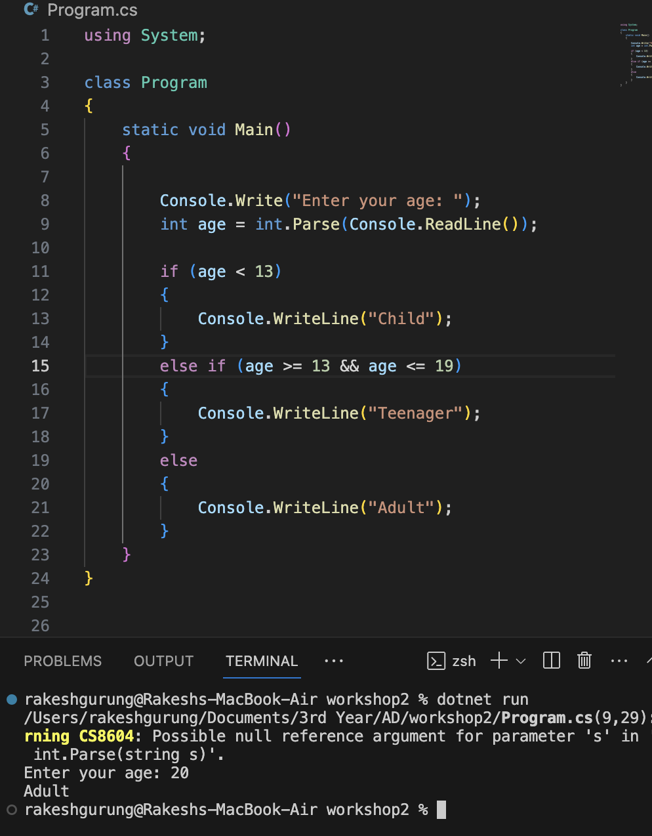
Task 4: If else and Switch
1. Ask user to input a number (1–7) and using switch, print the day of the week:

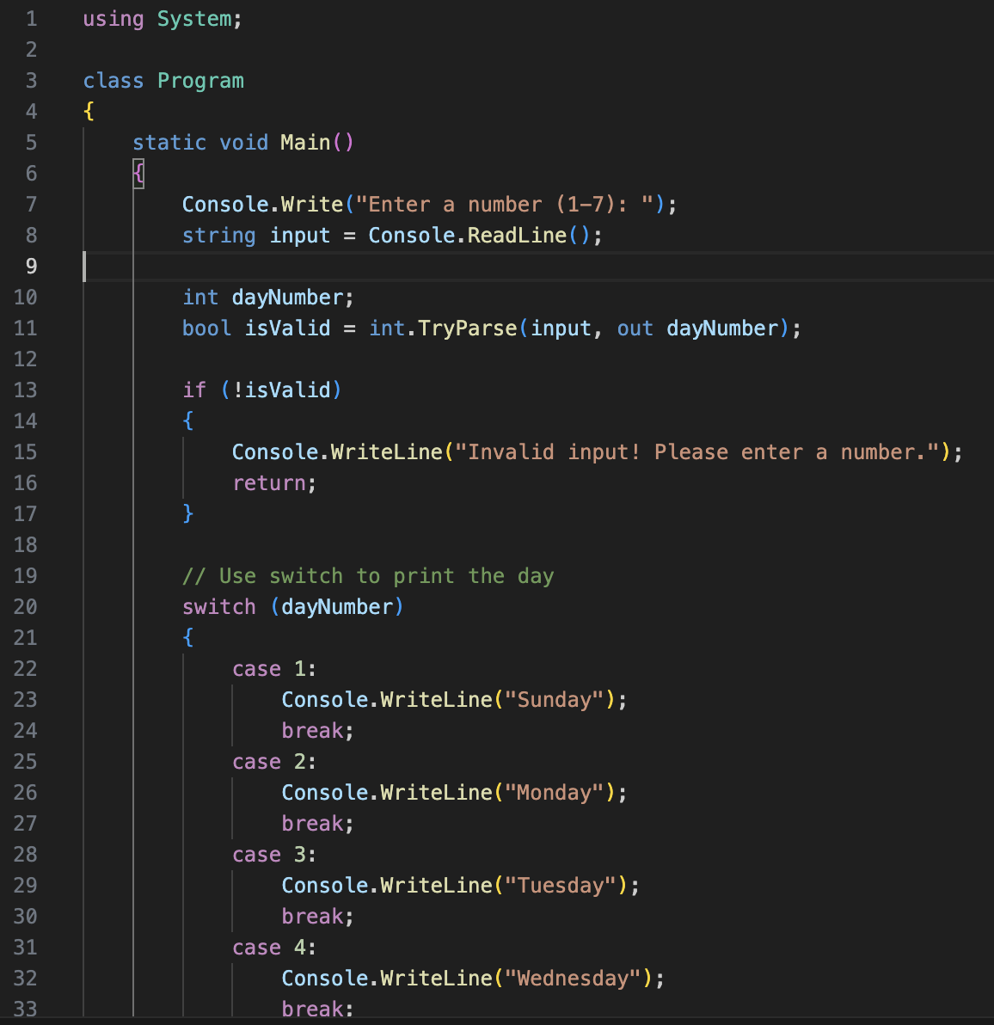
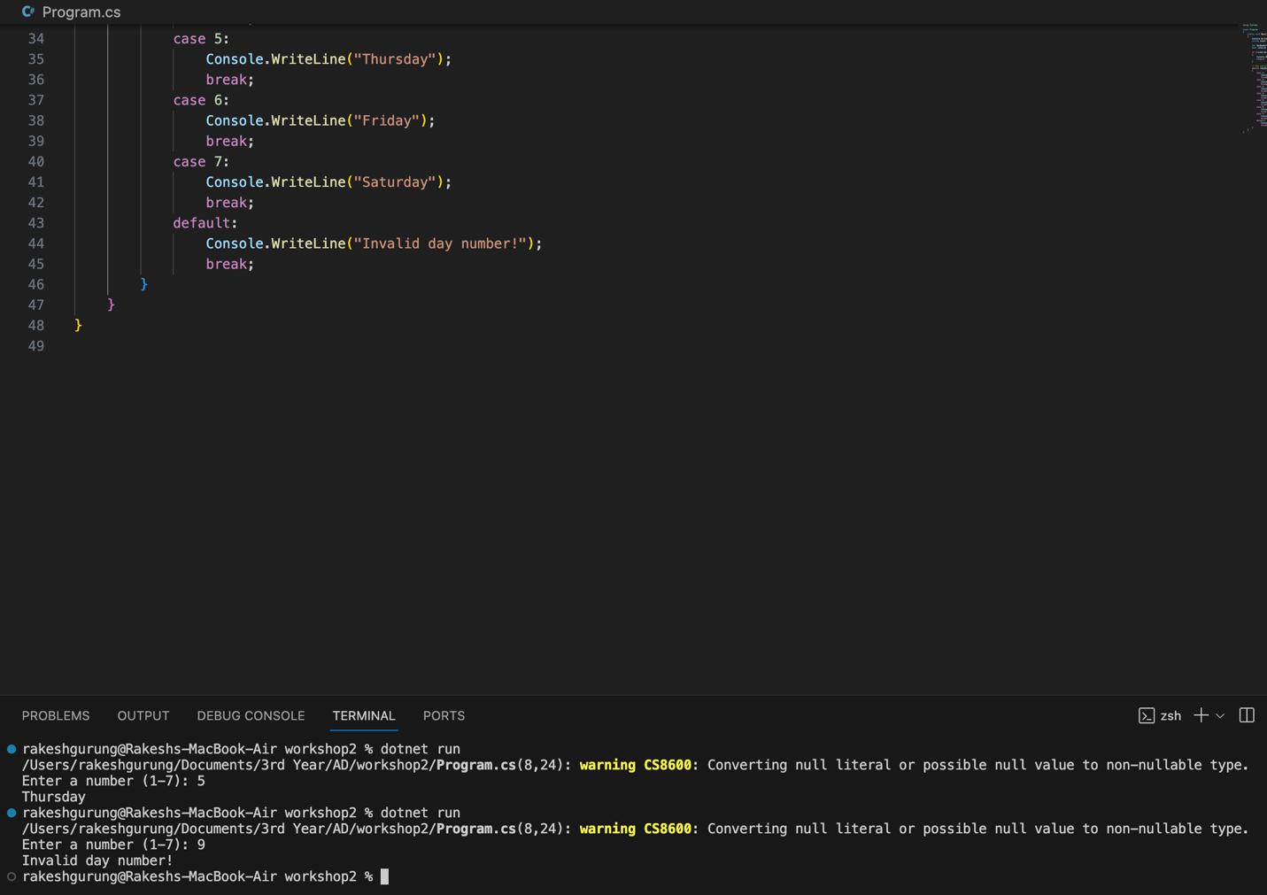

Task 5: Loops
- Ask the user to input a number N.
Using a for loop, calculate and print the sum from 1 to N.
• Example: Input: 5 → Output: 15
- Print numbers from 1 to 20 using while loop:
• Skip (continue) multiples of 4
• Stop (break) when number is 15
- Write a program to find the sum of all elements in an array using a foreach loop.

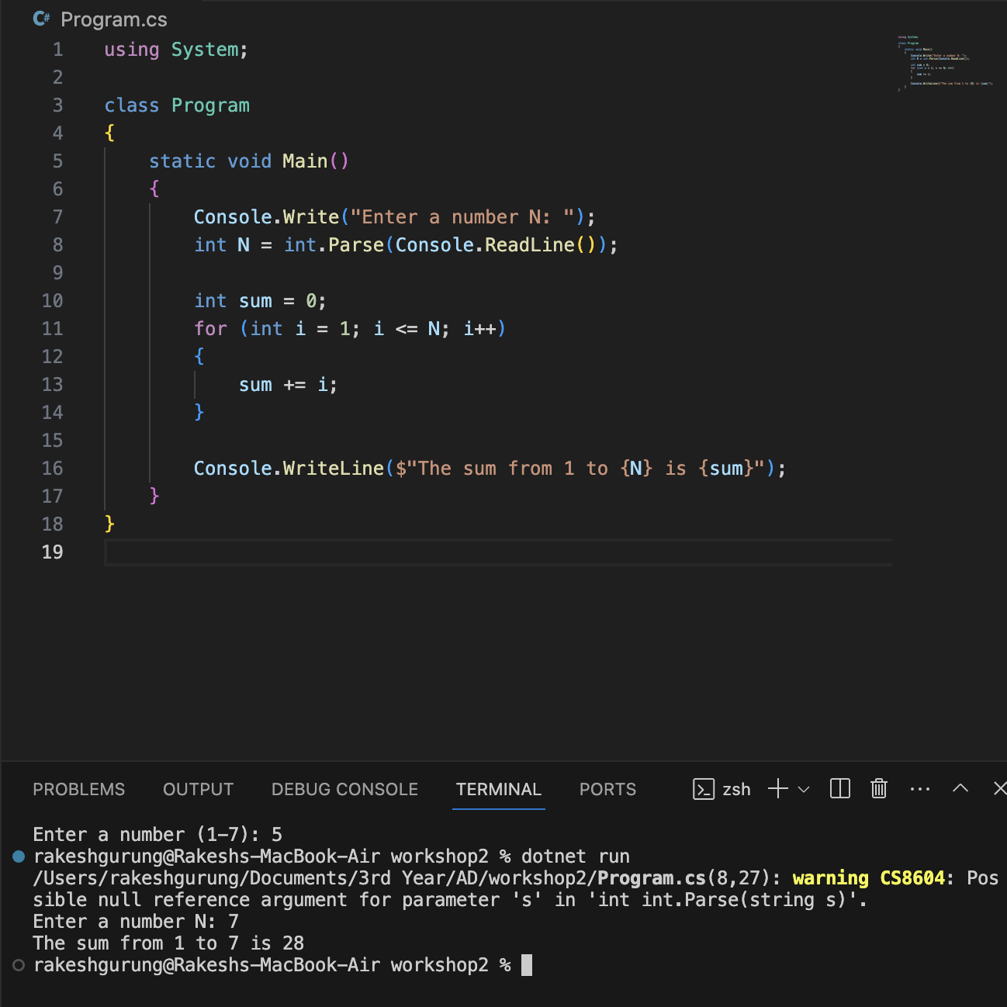
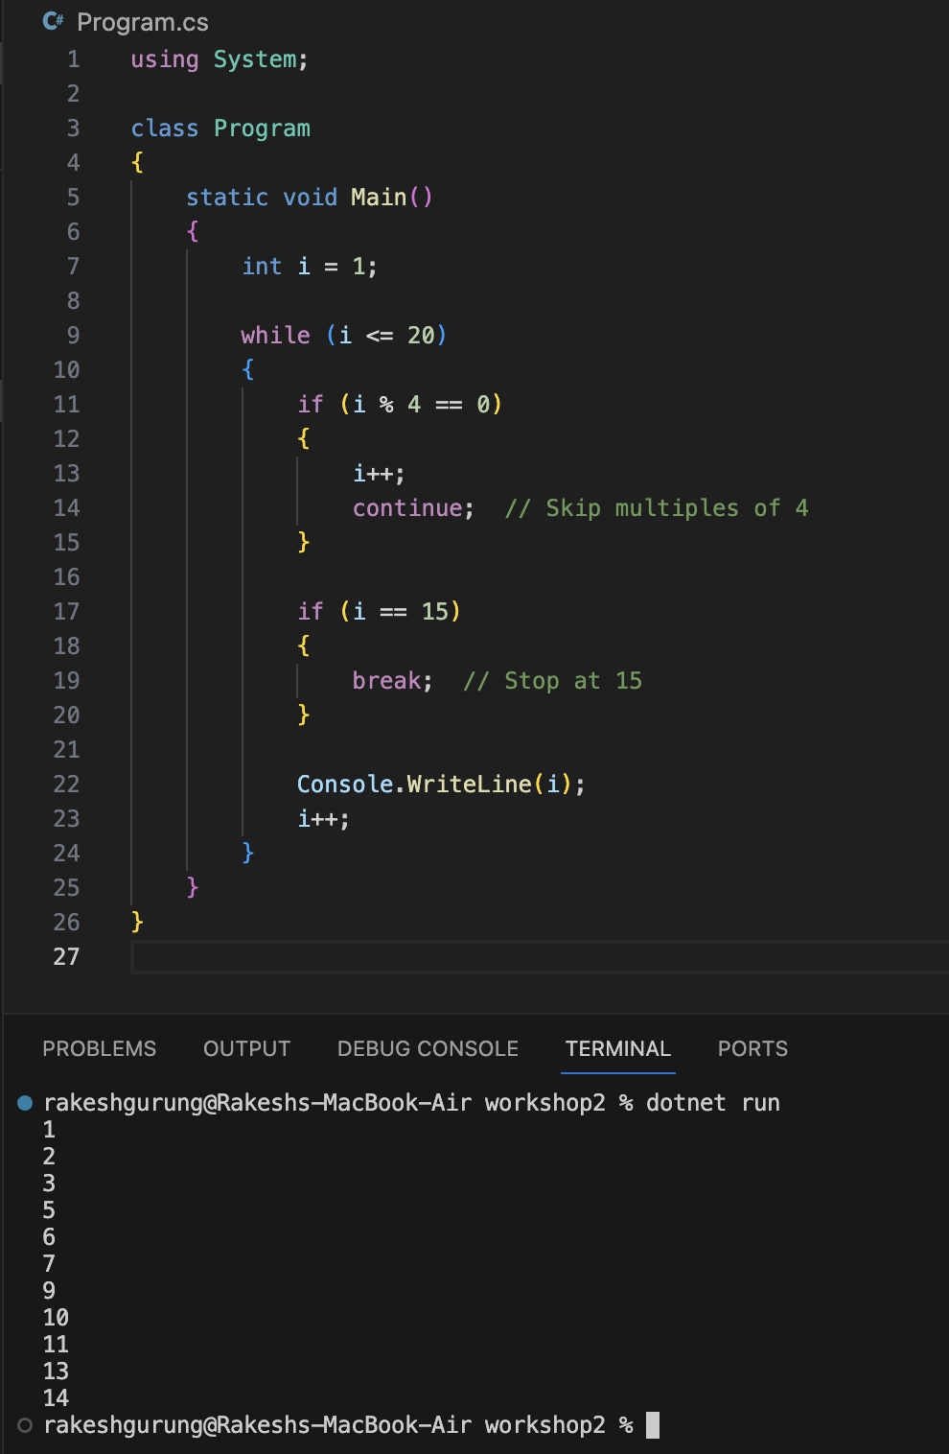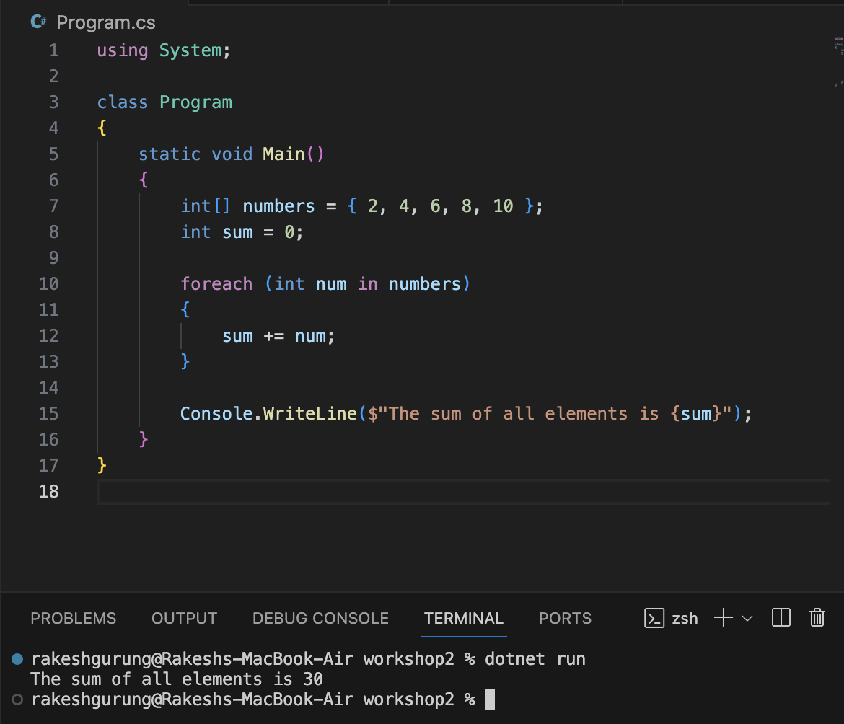

Task 6: Try Catch Finally
- Write a program that accepts a number from the user and converts it to an integer.
o If user enters invalid input (e.g., letters), catch the exception and show:
"Invalid number format".
o Display "Program Executed" in finally block.
- Write a program that asks for a password.
o If password length is less than 6 characters, use throw to raise
exception:
"Password must be at least 6 characters."
o Otherwise, print "Password satisfied the requirement".

